**JavaScript Assignment 13 :**  **Arrays And Functions**

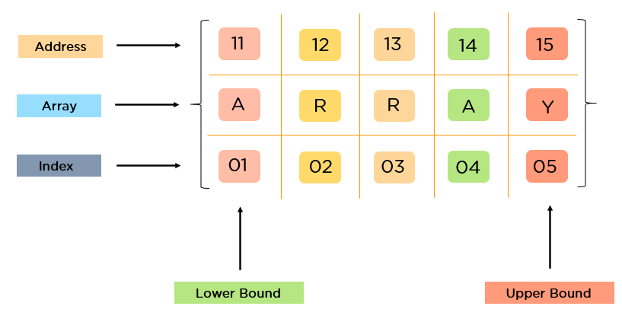

**Objective:** The objective of this assignment is to create JavaScript functions that receive an array as argument and perform various operations on it, including finding the maximum number, calculating the sum of all elements, and counting the number of odd numbers.

[Link1](https://www.youtube.com/watch?v=0SyTDl4pb4w)

[Link2](https://www.youtube.com/watch?v=u_lLNH38n5E)

**Tasks:**

Write JavaScript functions that perform the following operations on an array:

* Find the maximum number in the array.
* Calculate the sum of all elements in the array.
* Count the number of odd numbers in the array.
* Use a dummy array for testing purposes.
* Display the results of each operation to the user on Console.log.

**Instructions:**

Try to use different types of function like arrow function, anonymous function and so on.

Every function would take an array and perform its task.

**Sample Output**:

* Ex Array:- [4, 8, 2, 11, 6, 7, 10]
* Maximum number: 11
* Sum of all elements: 48
* Count of odd numbers: 2

**Submission Guidelines :-**

* Deploy your code to netlify make sure to name your html file as index.html.
* If you don’t know how to deploy on netlify, watch this video : <https://youtu.be/Ii2Y4i4_i-o>
* Submit the Deployed Link below in the same task number

Submit the deployed link here: [https://upskillmafia.com/mern/dashboard/tasks](http://upskillmafia.com/mern/dashboard/tasks)

|  |
| --- |
| **Note :** You can take help from **Internet** or You can also connect with upskill Mafia **Mentors** |